GIS Lab 1: Adding data, Projections, GIS tools

The biggest issue when beginning a GIS analysis is finding the data. Thankfully, free GIS data are available on the internet. Most political entities in the US have GIS data available and much of it is free if you know where to look. For example, NYC has many GIS files available through https://opendata.cityofnewyork.us/. Another useful source of free GIS layers is through https://naturalearthdata.com.

Here, we will download GIS data to create a map following a simple example but use your own data if available!

Part 1: Download data from GBIF

- Go to www.gbif.org and take some time to read about the organization. While you are here, register a new account to download the data in the next steps.

- Search a species of interest. The species used in this example is the Ambystoma opacum. After searching the Ambystoma opacum, a link should show up. Click on that link. On the top right corner of the page there should be a green button entitled Occurrences. Click on that.

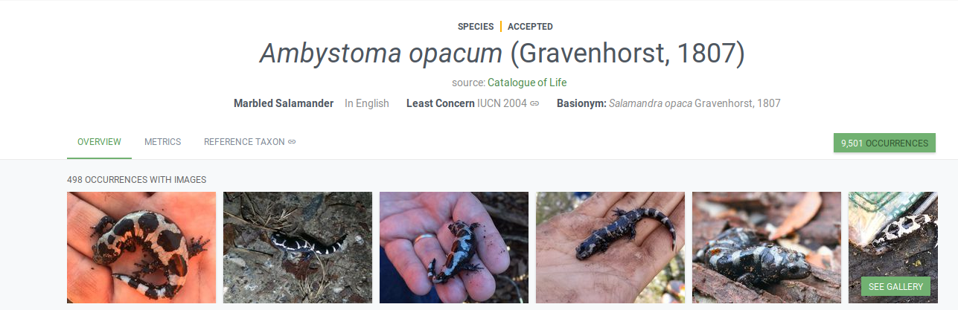

- You should see a table with a list of occurrences. On the bar above there should be a section named Download. Click this.

- Login in or create an account. Once you have done that, select Darwin Core Archive. Results of your query will be emailed to you.

- The download may take a few minutes. (If it takes too long, you can use the previously downloaded file).

- Save the zip file that is generated and extract the files.

- We are going to import the occurrence points into QGIS. To do this, we first need to convert “occurrence.txt” into a comma separated file, formatted as below. This can be done by importing into a spreadsheet (e.g. in Microsoft Excel [not Mac’s TextEdit]); click column A, “Scientific name”, go to the Data tab, and then select Text to Columns > Delimited > Tabs; repeat this process for decimalLatitutde”, and “decimalLongitude” columns. Copy and paste the three columns you want, “species”, “decimalLatitutde”, and “decimalLongitude”, into a new spreadsheet. Note that it is preferable with these kinds of files to avoid column headings and names consisting of two parts (you can use the underscore “_”. e.g., change “Scientific name” to “species”; “decimalLatitude” to “latitude”; “decimalLongitude” to “longitude”; and “Ambystoma opacum” to “Ambystoma_opacum”). Reorder the columns into the following order: Species, Longitude, Latitude, and save as comma separated (make sure the file ending is .csv, not.txt; Mac users: save as “MS-DOS Comma Separated”). Save this new file as “marb_salam.csv.”

Note that this type of file could be created from other sources of data, for example using a GPS unit.

Part 2: Import the data into QGIS

Now, launch QGIS and open a new, empty project. We will import the occurrence records using: the Add Delimited Text Layer button:, or go to Layer> Add Layer> Add Delimited Text Layer. Select the text file (e.g., marb_salam.txt) and the software should recognize the longitude column as X and the latitude column as Y (you could import data in any geographic or projected coordinate system). Then, we have to select the proper coordinate reference system at "Geometry CRS". GBIF data is projected to WGS84, so we will use “Project CRS: EPSG 4326 – WGS84”.

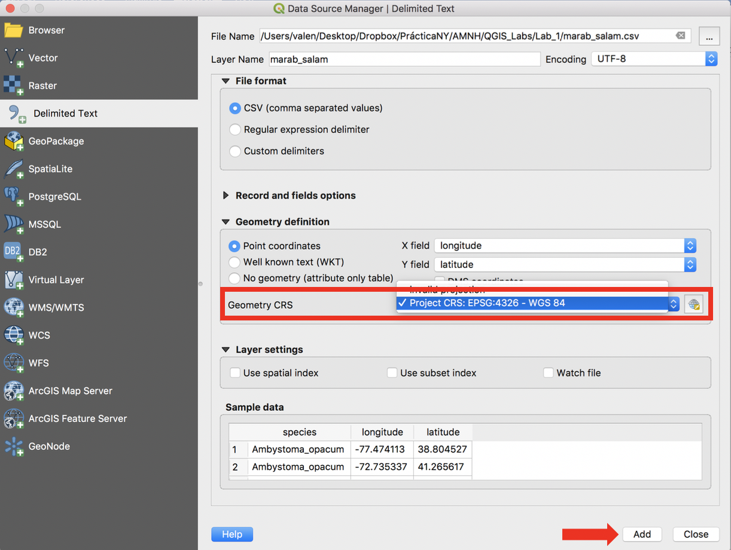

Hit add. and you should now be able to see your points!

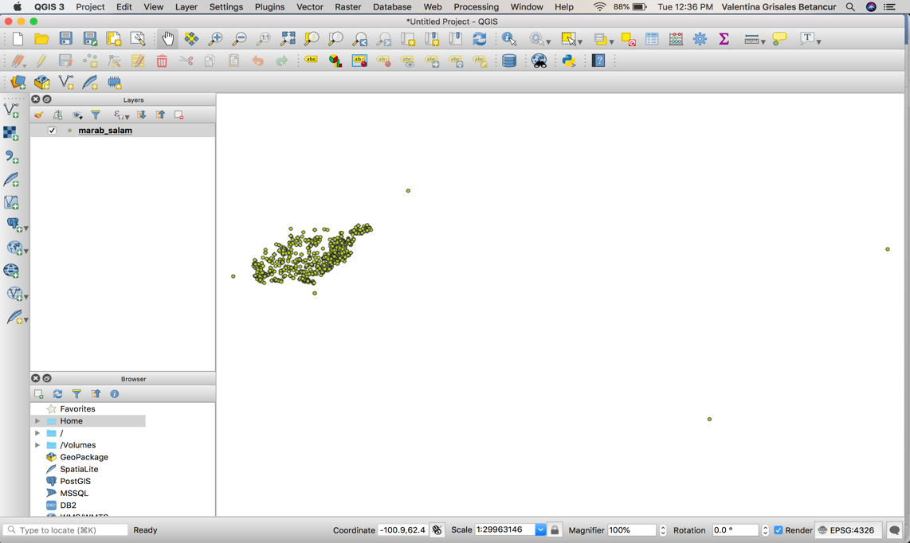

- Although we can now see the points, in order to create an ESRI point file that can be easily analyzed, we will convert to a shape file (.shp extension). A shape file is a layer file of points, lines, or polygons (vectors) that can be added to a map and easily manipulated in a GIS. In order to do this, right click (For mac users, hold down control and click) on the points layer in the layer panels window on the left and select Export > Save feature as. Name and save the file in the correct directory (Mac users: select the correct folder to save the file). Make sure the Format is ESRI Shapefile. The new shape file will open automatically and we should be able to see it in the layers panel

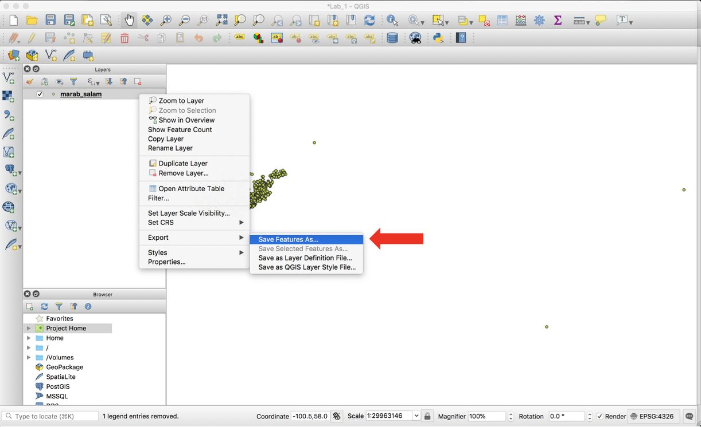
The data will look identical to the original, but the new shape file will be easier to manipulate.

Notice that you can turn different layers on and off using the tick boxes next to the layers. Turn off your original xy point layer from the text file so that only your new shape file is turned on.

Note: shape files produced by QGIS consist of multiple individual files that can be difficult to deal with in a normal file browser (e.g., Windows Explorer). In order to, say, delete or copy a file, be sure to move all files with that name, no matter the extension.

- At this stage it is useful to save the entire QGIS document: Project>Save As. This will save a .qgs file. The qgs does not affect the GIS layers, but instead saves the project you are working on, so if you close down and restart you will be at the same point (e.g., same layers loaded, same color schemes etc.).

Part 2: Download data from Natural Earth.

Head over to naturalearthdata.com and download some vector data for the region of interest. Click on “Get the Data” :
You can see that the data available here are open for anybody to use with proper citation.
You will notice that this website offers data in three scales; from Large to Small. Let’s download Large-scale State shapes. Go to Large scale data → Cultural → Admin1 – States, Provinces. Download and unpack the file into a single directory that you will be able to find later (i.e., not in your downloads folder). The more time you spend in data management now, the easier your GIS experience will be.

Add the layer to QGIS:
Data can be added to QGIS in two main ways. The first way is through the “Manage Layers Toolbar”:

If you can not find this toolbar, right click any empty space in the Main Toolbar and check the box for “Manage Layers Toolbar”. Here, click on the “Add Vector Layer” button (remember you can hover over the button) and navigate to the .shp file (remember: QGIS expects the ancillary shape data to be found in the same directory). The second, and easier way to add data to QGIS (this does not work for delimited text layers) is simply dragging and dropping the .shp file into the main QGIS map window. To view the occurrences on top of the shapefile, drag that layer to the top of the Layers Panel.

Change the projection
As you explore and pan the map, you’ll notice that this map looks a bit distorted.
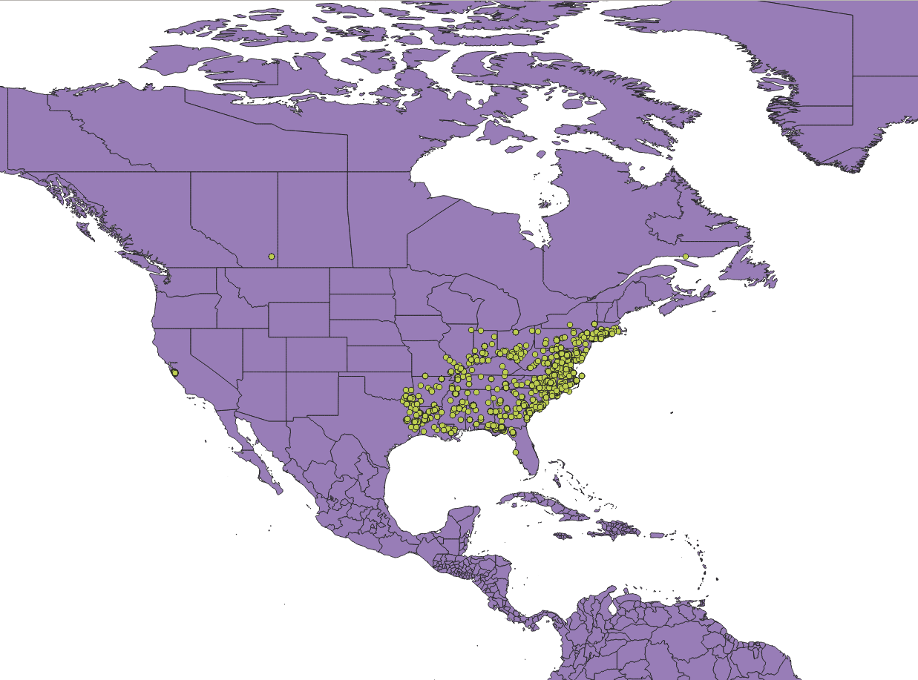

QGIS sets the coordinate reference system (CRS) to WGS 84 by default. You can assign the spatial reference using button in the lower right hand corner of the QGIS window . Select one of the conic projections (here, Albers Equal Area projection for North America works well).

Also spend some time exploring the toolbars, which enable you to zoom in and out, identify different features, and measure distances.

The toolbar looks like the above, embedded, or could be ‘floating.’ If it is not showing, right click in the gray area at the top and enable the “Manage Layers Toolbar”.

Try using the Zoom full button 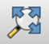. Are all of your data points where you would expect them to be? Use the pointer to figure out the X,Y coordinates for any odd points – what might be wrong with them?

If you have erroneous data points, they can be easily removed. Right click the layer in the Layers Panel and find the “attribute table”. The attribute table shows the data frame that was imported to create this layer. Click on the icon that looks like a pencil; this will enable “Toggle editing mode”. Select the row corresponding to any locality that you want to remove, then click on the red trash can icon to “Delete selected features”.

Finally, we can draw and export a map with a title, legend, or other labels. To do this, click on Project in the top left corner of the screen. You should see an option named New Print Layout. Click on that. A new window should pop up. Name that window “MarbSalam.”

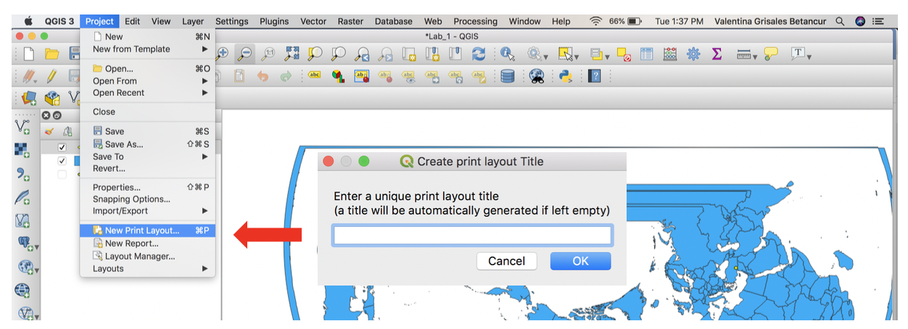

Here, click Adds a new Map to the Layout 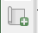. Then, drag a square to fit the white canvas. Your map view will be put into this square. You can use the toolbar to select the area that you want to map: the zoom tools move in and out, and Move item content moves the image. It is also easy to add a legend, a north arrow and a scale bar from the side toolbar. Use the Layout tab in the right hand of the window for adding items to the map. For a north arrow: Add image > drag a small rectangle> Item Properties > Search directories > Select north arrow from the list. With a little experimentation, you can soon draw a presentable map. Explore the toolbar more and find “Add Legend”. See if you can make the occurrences and administrative layer appear neatly in a legend.
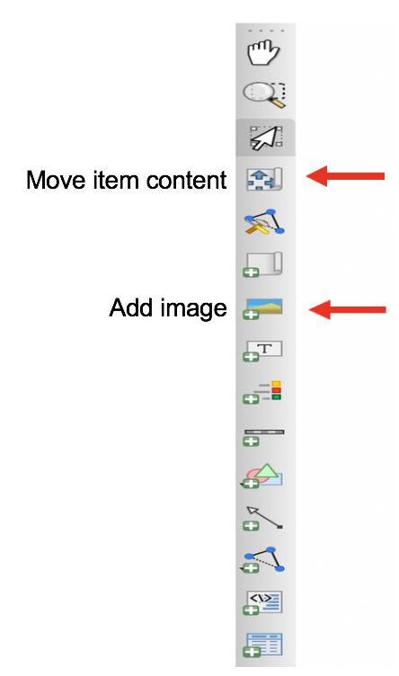
To export the map and save it as an image file (e.g., jpg), use Layout > Export Image. You now have a map image external to the GIS.

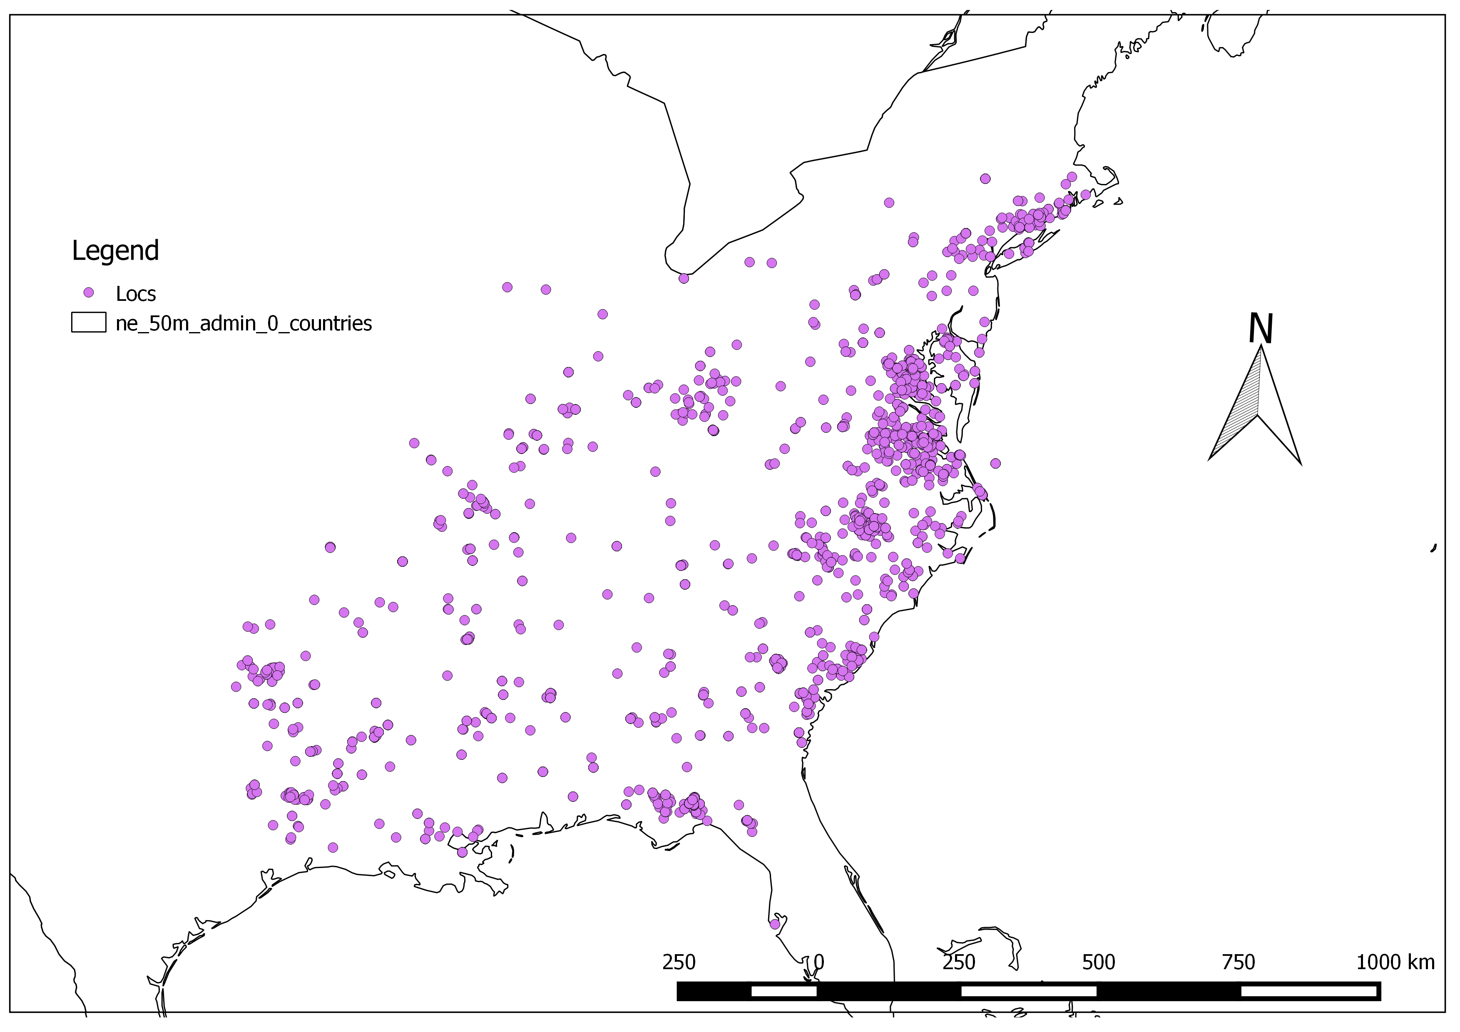

In powerpoint or an image editor, you can update your Legend to include appropriate labels (like scientific name, italicized) and units, and a clear description of what each layer in your map represents.

