Objectives:
Vector manipulation is an important GIS tool. Querying shapefiles and saving independent data subsets can help you save time and memory, simplify your project, and allow for better projection visualization. You can also directly edit the shapefiles to remove errors, or fix resolution issues. You can create and edit fields within a shapefile, and you can join data from other tables.
In this lab you will learn how to:
- Query and subset a shapefile
- Edit vertices
- Edit fields
- Perform vector operations
Query and subset a shapefile
- Using either the “Add Vector Layer” button or the drag-and-drop method, add the global States and Countries shapefile.

- Using the “Select Features by area or single click” tool, select the northeastern US states. Remember, you can hold shift (or Windows:ctrl, or Mac:cmd) and click on multiple features. Then export this as a new ESRI shapefile.
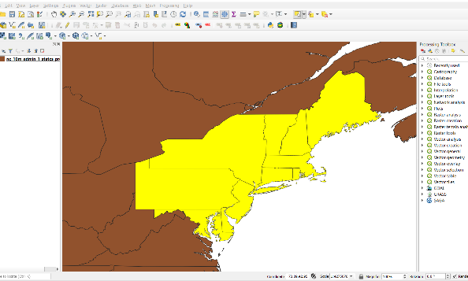

- The new file should be automatically loaded onto the map. In the Table of Contents, turn off the global layer so only the new one is showing. This is one way to subset a shapefile by feature. Another way is by using the attribute table. Open the attribute table and scroll over to the “name_en” field. By clicking on the row numbers and holding either the Ctrl or Cmd keys, highlight New York, Pennsylvania, Vermont, New Jersey, Massachusetts, and Connecticut.
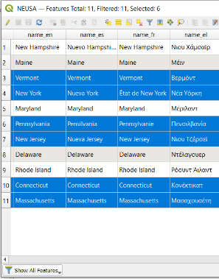

- Notice how these states are now highlighted on the map. Try using the “Identify Features” () tool to check a few states. Another way we can select features is by using the “Select by Expression” () tool. It is easiest to let this tool help you create the expression. Here, we are going to select features whose “name_en” is Maine.
  - In the search bar, type in “name_en”. Under Fields and Values, double click “name_en” to add it to the expression pane on the left side. Then click on the “=” button below the pane.
  - Now you need to add the name of the state. Since syntax is very important when using this tool, again it is best to let the tool help.
  - In the right third of the pane, click on “All Unique”. This will show all of the unique values of name_en. Double click on “Maine” to add it to the expression pane.
  - Finally, click on the down-arrow next to Select Features and choose “Add to Current Selection”. Now you will see that Maine has been added to the selected states.
  - Save this selection as a new shapefile layer named “states”.

- Finally, we can subset vector data by selecting features in relation to other layers. Subset the bigfoot occurrences by only those that are in the Northeast United States (excluding New Hampshire and Rhode Island). In the Processing Toolbox, search for “Select by location” and open the Select by location tool.
  - Here, we want to Select features from: bigfootSightings.
  - Where the features are within. Check only the “are within” box.
  - By comparing to the features from “states”.
  - Click “Run” and see the occurrences selected. Save these as a new shapefile layer named “NEbigfoot”.
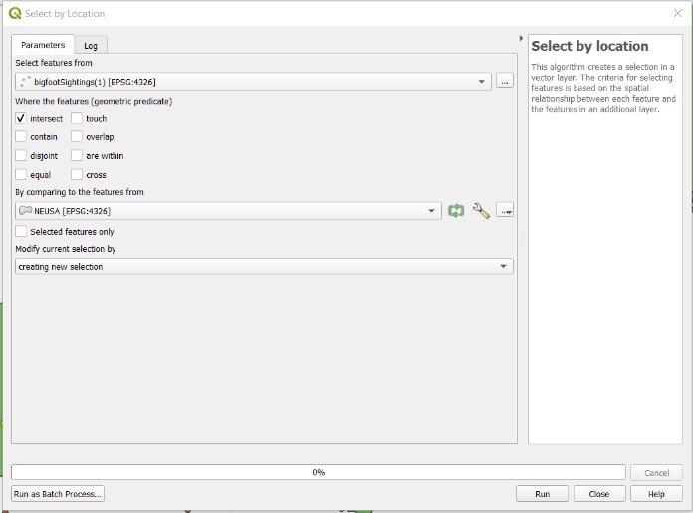

Editing a shapefile
- We can also edit and move polygon features in QGIS. There is a bigfoot occurrence that is too close to the Jersey Shore, making it highly unlikely. Move that occurrence record westward into central New Jersey.
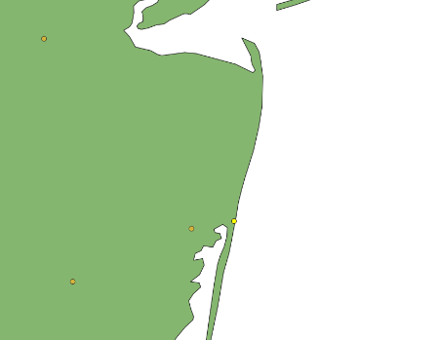

  - Using the “Select features by area or click tool”, select this occurrence record. Then, open the attribute table of the layer. In the lower corner of the attribute table, click on the drop-down menu and change it to “Show Selected Features”. It should be the only feature highlighted. Take notice of the latitude and longitude. We will have to update these to match the new coordinates.
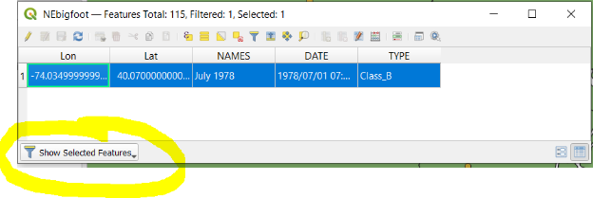

  - Next, use the Toggle Editing tool (). You may need to make sure the Editing Toolbar is enabled. The editing tool will allow you to change features of the layer that is selected in the Layers Panel (Table of Contents). Next, using the Vertex Tool (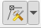), click on the locality in question, then click on the new location to where you would like to move the locality. The locality should now show in the new locality.
  - Now that you moved the locality, you need to update the attribute table. You can do this manually by editing the attribute table, but this opens the door for error. QGIS can also add the latitude and longitude of each feature using the Field Calculator () found in the Attribute Table. Using the field calculator, Create a New Field named “X”. Change the Output field type to “Decimal number (real)” with output field length of 10 and a precision of 5. In the Expression box, type in: $x. This will print the longitude value for all features. Do the same for latitude.
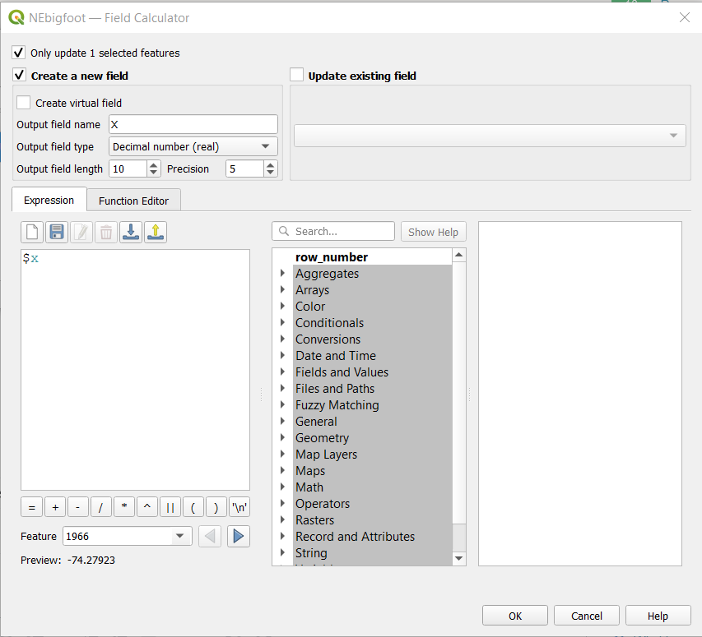
  - Now, replace the Lon and Lat values of the bigfoot locality that you moved such that they reflect the new location calculated using the X and Y method. Click the Toggle Editing mode button again and save your changes.
Vector operations
- In this scenario, Connecticut’s Department of Energy and Environmental Protection wants to know the area of interest to search for bigfoots given where they have been observed. They also know that the occurrence closest to the Connecticut-Massachusetts border was actually observed within Connecticut. They have heard that bigfoots have a home range of about four miles. Calculate the total area of the four mile radii for all of the bigfoot occurrences.
  - First, move the occurrence near the Connecticut-Massachusetts border into Connecticut.
  - Using one of the selection methods covered already, create a new layer for both Connecticut, and all of the occurrences in Connecticut. Make these the only visible layers on your map.
  - Connecticut is interested in measuring using the imperial measurement system, meaning the map must be projected in a system that measures in these units.
    - Reproject both layers to “NAD_1983_2011_StatePlane_Connecticut_FIPS _0600_Ft_US” ESRI: 103016. Don’t forget to also set the project CRS to the same.
    - Rename both to something other than “Reprojected” (which is default).
  - Using the Processing Toolbox, search for “buffer”. Under “Vector geometry” open the Buffer tool. The input layer should be the newly reprojected bigfoot occurrences. Set the Distance to 4 miles. Leave the rest of the default settings for now and click Run. Rename the new layer “BigfootBuffered”.
  - Now, you need to calculate the total area of buffered points. NOTE: If you have overlapping buffers, you will need to use the “Dissolve” tool to merge them. ALSO: if your buffer exceeds the borders of Connecticut, you will have to use the “Clip” tool.
    - Open the attribute table of BigfootBuffered and open the Field Calculator. Create a new field named “Area” with Decimal numbers and a precision of 5. In the Expression box, type in “$area”. When you run this, it should create a new column of areas for each feature.
Create a map:
Make a map of bigfoot home ranges in Connecticut that one might present as a pamphlet or textbook image. The map should include all of the key map elements. The bigfoot data are from the Bigfoot Research Organization < Bigfoot Field Researchers Organization (bfro.net)>. The map should also include information on the area of bigfoot home range that exists within Connecticut (these values will depend on to where you moved the fourth occurrence). Think about the map units and if these are a meaningful unit of measurement for your map.

