GIS and remote sensing for conservation and evolutionary biology
Session 2: computer lab exercise

Aim: To view, clip, format and export environmental raster data.

Part 1: View and clip WorldClim climate layers

- For this exercise we will use the WorldClim Version 1 climate layers (Hijmans et al. 2005; https://www.worldclim.org/data/v1.4/worldclim14.html). First, spend a few minutes familiarizing yourself with the general information on the website. We will use the 30 second resolution (~1km²) present-day bioclimate variables. These data can be downloaded for free from the WorldClim website, but given that the files are large, and need some processing, you may need to do this before class. To download and format the data, go to the Version 1.4 link. We want to download the Current climate interpolations. Under Generic grid format, download both sets of zip files under bioclimatic variables at 30 arcseconds.

- Open a new empty Map in QGIS. Select the Add Raster Layer button 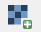 and navigate to the data you saved. The software will recognize that these data are raster layers. Sort the files by type, and load all of the “.bil” files (preferably use “.tif” if available. If not, go to Raster > Conversion > Translate (convert format) > under Converted set the directory and name > hit Run in Background. This process will take a while. Next, remove all layers from the table of contents (right click> remove), and drag in the ‘.tif’s you just converted.

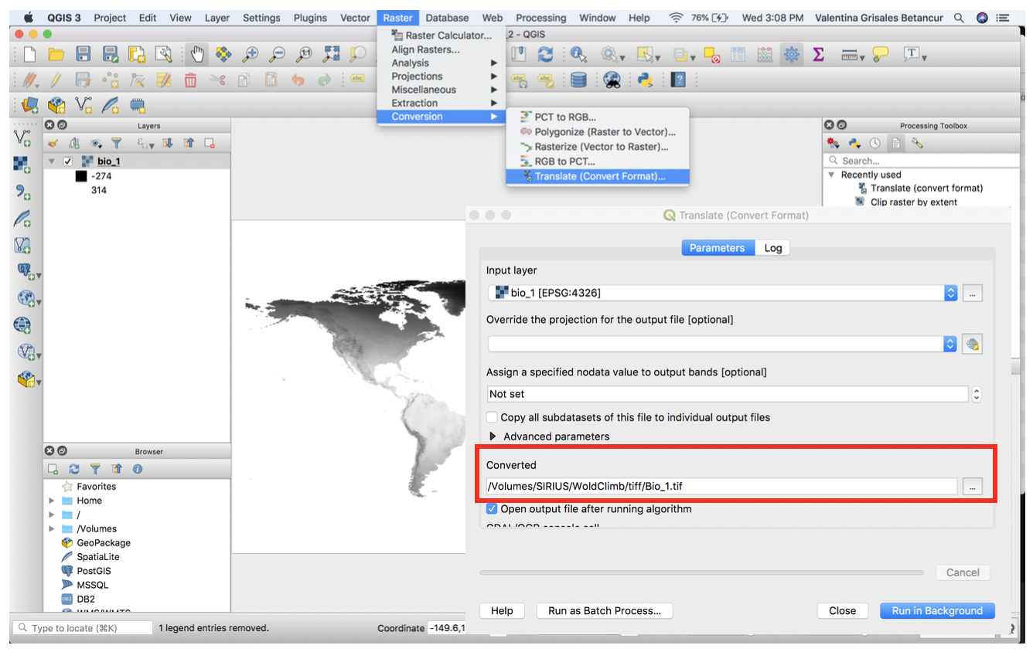
Don’t forget to save the new project (Project > Save As) and to keep saving regularly while working with the GIS.

- You should now see a global layer for mean annual temperature (bio_1; if this is not on top of your table of contents, drag it to the top). Notice that all values in this dataset are multiplied by 10 (e.g., 10 °C is stored as a value of 100); this is simply a way of storing the data more efficiently. Spend a few minutes exploring the data by zooming in to different regions (using the “Tools” toolbar
that we looked at last week) and playing with the symbology (double click on the layer in the layer panel > Symbology> under band rendering change render type to singleband pseudocolor > Under Min/max values settings, choose a color ramp, and click classify. Then, click OK.

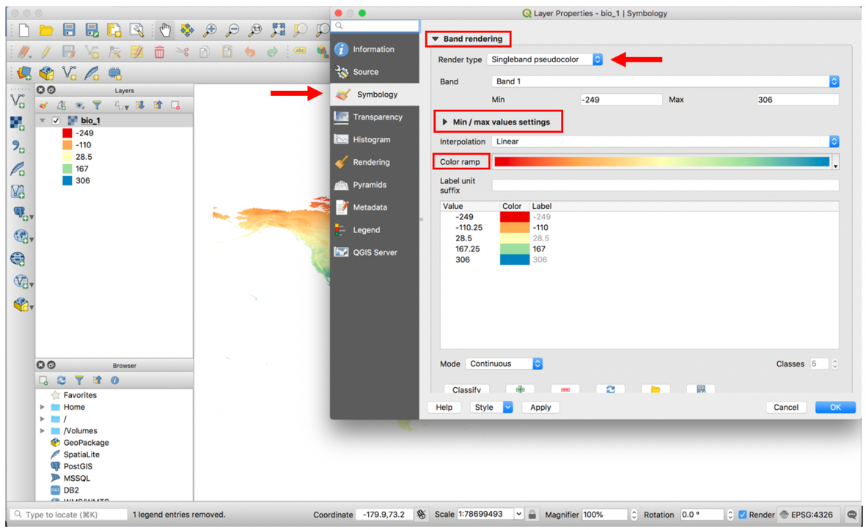

- We are next going to use two GIS tools that are extremely useful: (1) divide all values by 10 using Raster Calculator (in order to bring the values back to degrees Celsius, see #3), and (2) extract a region of interest using the “clip” tool.

- Raster Calculator is a simple, self-explanatory tool for manipulating raster layers. For example, you may want to multiply the values in two layers together, or (as here) divide all values in a layer by 10. In QGIS, go to Raster > Raster Calculator. Now, select the layer you want to manipulate (bio_1) by double-clicking it, select the name and directory of the Output layer, and then type the expression to divide by 10 – use the buttons, not your keyboard to type / 10:

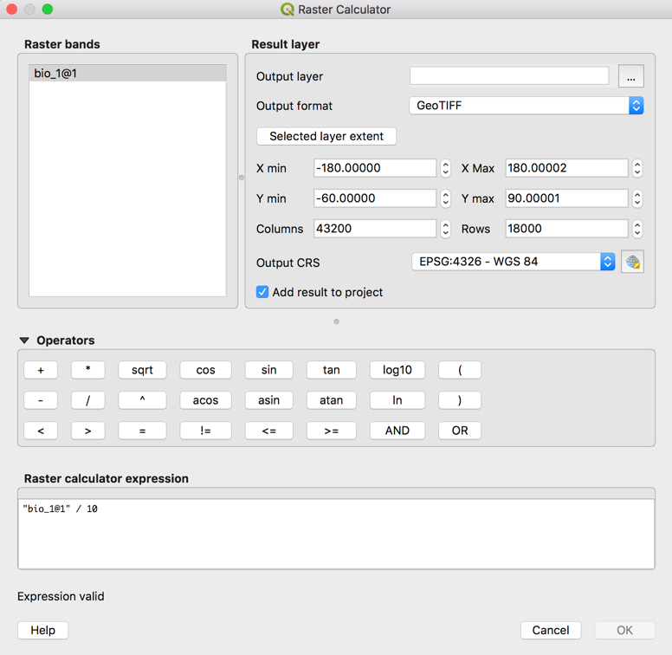

Hit OK! This may take a minute or two because the file that we are using is huge.

Tip: Don’t forget about the QGIS documentation online: www.qgis.org/en/docs/index.html

- The next GIS tool that we will use allows us to extract (or “crop”) a region of interest. We first need to know the coordinates that define the extent of our study area (i.e., the minimum and maximum x and y coordinates that define a rectangular area that encloses our study area). To do this we can take note of coordinates by placing the cursor on the map and viewing the coordinates in the bottom right of the screen:

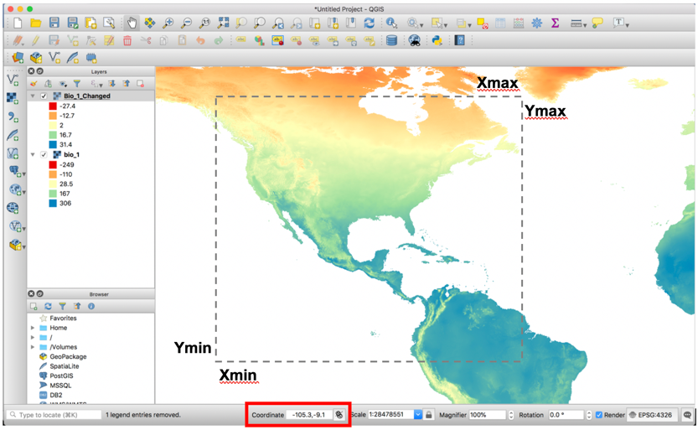

So, record (e.g., in a text document) the x and y coordinates that will enclose your study area. For example, you might place your cursor on the two points in the map above, and record these coordinates: min x = -103.057, max x = -51.625, min y = 15.139, max y = 52.582.

- Now we can use the Clip (Raster>Extraction>Clip Raster by Extent) tool. Under Clipping extent enter the coordinates defining your rectangle, or drag one on the map, and give the output raster a name, such as bio_1v2clip.tif (ignore the Advanced parameters for now).

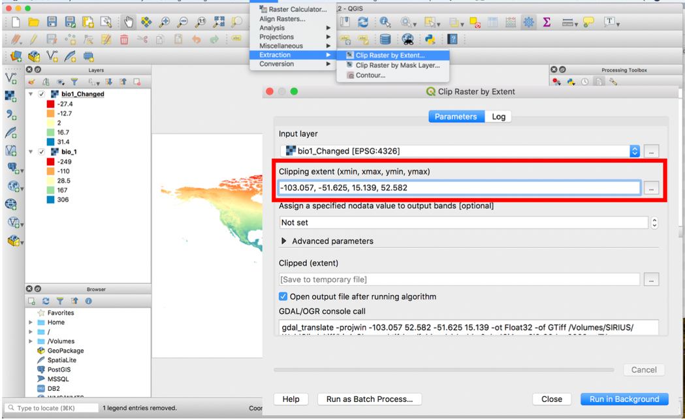

Hit Run in Background.

You should now have a new layer that is ‘clipped’ to your study region:

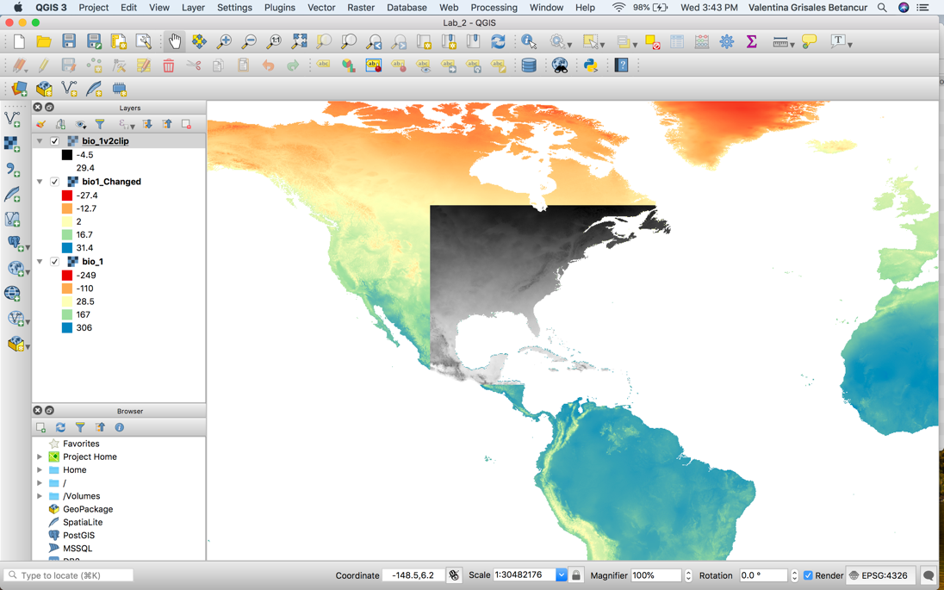
- You may want to now draw a map showing the environmental layers as well as the species occurrence points from week 1. So, use Add Delimited Text Layer to add your species occurrence records (.csv file) and Add Vector Layer to add the vector outline for the region. Use the print composer to create a map and export an image (e.g., jpg). You can change the resolution of the map by reducing the values in Item properties > scale. See if you can add a rectangle and give it the same color ramp used for the map. Don’t forget that you can ‘touch it up’ in a general publishing program, such as Microsoft Publisher or Adobe Illustrator.

Note: To add a rectangle to use as a color ramp, go to Add shape 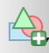 and draw the rectangle. Then go to item properties>Main properties>style>simple fill>change to gradient fill. Then click on color ramp and change the color.

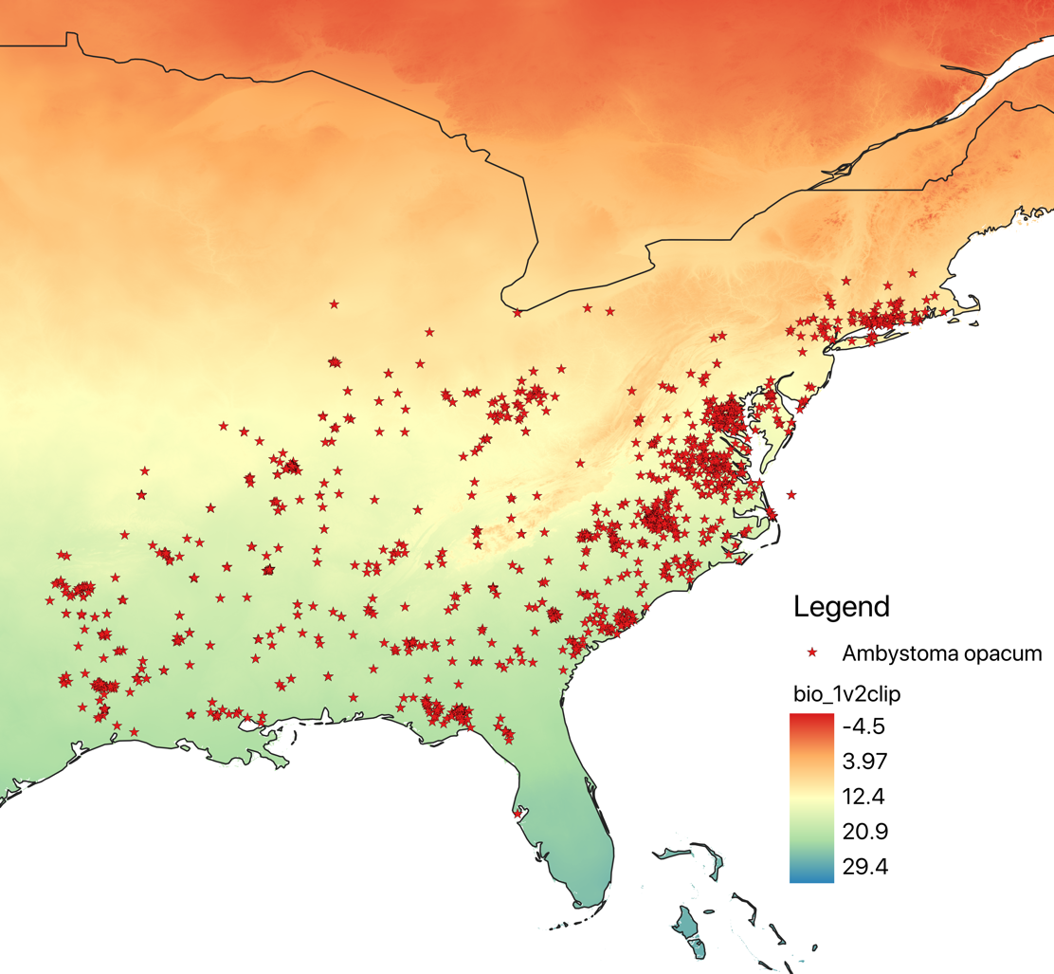

Part 2: Export clipped .tif files

So far we have dealt with only one environmental variable. However, in the applications we’ll look at later in the course we will want to use multiple variables (since species are rarely influenced by only one environmental factor; think about the niche concept, and Hutchinson’s notion of a multidimensional niche space – we’ll talk about this in detail in Session 4). So, for the final part of this exercise we will crop all 19 of the bioclim variables from WorldClim, which is easier now we have done it with one layer. We will then export cropped .tif grid files, which we will use later in the course (for species distribution modeling).

- We will first clip all 19 layers to match the extent of the one layer we have done. There are numerous possible ways to do this, but one option is use the GDAL tools available in QGIS. To start, load all 19 bioclim variables into QGIS. (either drag them from where they live, or use the Add raster layer button).

- Go to the Processing Toolbox (if it’s not there, go to Processing > Toolbox) and search “raster”. Under Extraction right click on Clip raster by extent and choose Execute as batch process.

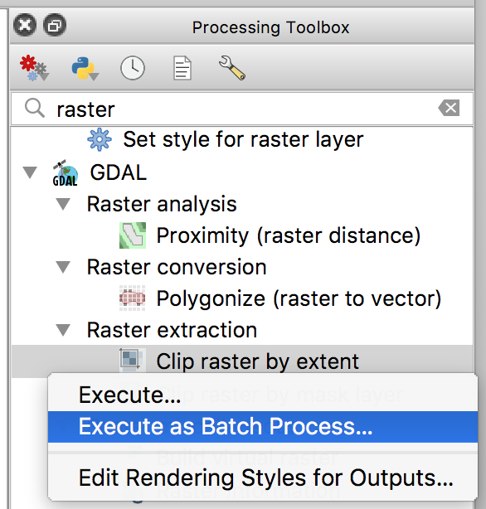

- Under Input layer, click the ellipses (…), and click Select from filesystem. Navigate to where your tifs are saved, and highlight all 19 and click open. Under clipping extent, enter the coordinates for your extent as X-min, X-max, Y-min, Y-max: -103.057, -51.625, 15.139, 52.582. Enter this value for the first cell, then double click on Clipping extent to fill all cells. Then enter the pathway to save the rasters under Clipped (extent), and give a unique name (“clip”). QGIS will then prompt about how to autofill the names. Change Autofill mode to “Fill with parameter values” and Parameter to use to “Input layer”. Then run the clipping tool.

- To divide the new layers by 10, we can use the Raster Calculator again. All we need to do is select a layer, divide by 10, and click OK (see step 5 above).

That’s all for this session! You now have a set of environmental raster files that can be used alongside the occurrence records from session 1 in analyses we’ll do later in the course.

